Profile of the

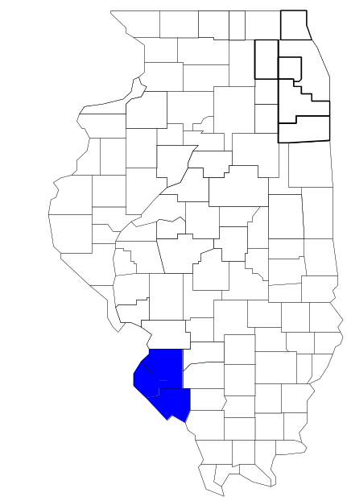Metropolitan Enforcement Group
of Southwestern Illinois

Prepared by

The Research and Analysis Unit of the
Illinois Criminal Justice Information Authority

George H. Ryan, Governor
Peter B. Bensinger, Chairman
Candice M. Kane, Executive Director

March 2001

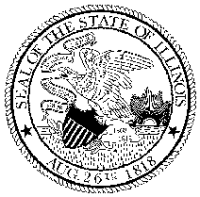

ILLINOIS
CRIMINAL JUSTICE
INFORMATION AUTHORITY

This project was supported by Grant # 99-DB-BX-0017, awarded to the Illinois Criminal Justice Information Authority by the Bureau of Justice Assistance, Office of Justice Programs, U.S. Department of Justice. The Assistant Attorney General, Office of Justice Programs, coordinates the activities of the following programs, offices and bureaus: Bureau of Justice Assistance, Bureau of Justice Statistics, National Institute of Justice, Office of Juvenile Justice and Delinquency Prevention, and the Office for Victims of Crime. Points of view or opinions contained within this document are those of the authors and do not necessarily represent the official position or policies of the U.S. Department of Justice.

Illinois Criminal Justice Information Authority
120 S. Riverside Plaza, Suite 1016
Chicago, Illinois 60606-3997
Telephone (312) 793-8550
Telefax (312) 793-8422
TDD: (312) 793-4170
World Wide Website http://www.icjia.state.il.us
ACKNOWLEDGMENTS

A number of organizations and individuals put a great deal of effort into the development of this document. The Authority’s Research and Analysis Unit is very grateful for the assistance provided by the following organizations:

Administrative Office of the Illinois Courts
Illinois Department of Human Services’ Office of Alcoholism and Substance Abuse
Illinois Department of Children and Family Services
Illinois Department of Corrections
Illinois State Police
Metropolitan Enforcement Group of Southwestern Illinois
U.S. Bureau of the Census

In addition, the following individuals were instrumental in gathering, interpreting and presenting these data:

Sharyn Adams

Megan Alderden

Robert Bauer

Alissa Clark

John Condne

Karen Griffiths

Tracy Hahn

Jennifer Hiselman

David Katz

Joseph Kozenczak

Gary Kupsak

Erica Morrow

David Olson

Adrianna Perez

Gerard Ramker

Robert Taylor

CONTENTS

Section Page Number

EXECUTIVE SUMMARY

I. Introduction 1
II. Trends in Violent Index Offenses and Arrests 3
III. Trends in Drug Arrests 6
IV. Trends in Drug Seizures 14
V. Trends in Prosecutions for Drug Offenses 16
VI. Trends in Percent of Convicted Drug Offenders Sentenced to Prison 18
VII. Trends in Drug Treatment Admissions in Madison, Monroe and St. Clair Counties,
by Drug Type 23
VIII. Trends in Drug Exposed Births 26
IX. Summary of Drug Situation 27
X. Appendices 29
Map 1 1999 Percent of Illinois' County-level Population Covered by an
Authority-funded Multi-jurisdictional Enforcement Group or Task Force 30
Map 2 1999 Illinois Cannabis Seizure Rates, by County 31
Map 3 1999 Illinois Controlled Substances Seizure Rates, by County 32
Map 4 1999 Illinois Methamphetamine Seizure Rates, by County 33
XI. Bibliography 34

LIST OF FIGURES

Figure Page Number

Figure 1. Violent Index Offense Rates for Participating and Non-participating Agencies in Region Covered by MEGSI 3
Figure 2. 1999 Violent Index Offenses* Reported by Participating and Non-participating Agencies in Region Covered by MEGSI 4
Figure 3. Violent Index Arrest Rates for Participating and Non-participating Agencies in Region Covered by MEGSI 5
Figure 4. 1999 Violent Index Arrests* Reported by Participating and Non-participating Agencies in Region Covered by MEGSI 5
Figure 5. Total Drug Arrest Rates for MEGSI and Participating and Non-participating Agencies in Region Covered by MEGSI 7
Figure 6. 1999 Drug Arrests* Reported by Participating and Non-participating Agencies in Region Covered by MEGSI 7
Figure 7. Total 1999 Drug Arrests* Reported by Participating and Non-participating Agencies in Region Covered by MEGSI, by Drug Type 8
Figure 8. Drug Arrests by MEGSI 9
Figure 9. Percent of Total Drug Arrests Accounted for by MEGSI 9
Figure 10. Cannabis Arrests Rates in Madison, Monroe and St. Clair Counties as Reported by Participating Agencies, Non-participating Agencies and MEGSI 10
Figure 11. Percent of Cannabis Arrests Accounted for by MEGSI
11
Figure 12. Controlled Substances Arrest Rates in Madison, Monroe and St. Clair Counties as Reported by Participating Agencies, Non-participating Agencies and MEGSI 12
Figure 13. Percent of Controlled Substances Arrests Accounted for by MEGSI 12
Figure 14. MEGSI Drug Arrests for Possession versus Delivery, by Drug Type 13
Figure 15. Cannabis Seized and Submitted by Madison, Monroe and St. Clair Counties and Seized by MEGSI 14
Figure 16. Powder and Crack Cocaine Seized and Submitted by Madison, Monroe and St. Clair Counties and Seized by MEGSI 15
Figure 17. Number of Felony Filings in Madison, Monroe and St. Clair Counties 16
Figure 18. Total MEGSI Drug Arrests and Percentage of Arrests Resulting in Prosecution 17
Figure 19. Sentences Imposed on Felons Convicted in Madison, Monroe and St. Clair Counties
18
Figure 20. Sentences Imposed on Convicted MEGSI Drug Offenders 19
Figure 21. Number of Drug Offenders Committed to IDOC by Madison, Monroe and St. Clair Counties and MEGSI 20
Figure 22. Drug Offenders as a Percent of Total IDOC Commitments from Madison, Monroe and St. Clair Counties 21
Figure 23. Drug Offenders Committed to IDOC from Madison, Monroe and St. Clair Counties, by Offense Class 22
Figure 24. Substance Abuse Treatment Admissions from Madison, Monroe and St. Clair Counties 23
Figure 25. Comparison of Drug Arrests by MEGSI and Participating and Non-participating Agencies vs. Drug Abuse Treatment Admissions in Madison, Monroe and St. Clair Counties 25
Figure 26. Cases of Drug-Exposed Infants in Madison, Monroe and St. Clair Counties 26
Figure 27. Availability of Drugs in Illinois, 1998 27
Figure 28. Price Per Gram in Illinois, 1998 28

EXECUTIVE SUMMARY

Since 1989, the Authority’s Research and Analysis Unit has received funds under the federal Anti-Drug Abuse Act of 1988 to document the extent and nature of drug and violent crime in Illinois and the criminal justice system’s response to these offenses. As a result of these efforts, the Authority has amassed a large amount of data measuring the extent and nature of drug and violent crime in Illinois and the impact these crimes have had on the criminal justice system. In addition, as part of its monitoring and evaluation efforts, the Authority also requires funded programs to submit monthly data reports describing their activities and accomplishments. This profile is intended to provide a general overview of the drug and violent crime problem in the jurisdictions covered by Illinois’ MEGs and task forces, and the response to these problems by the units.

Although the data presented in this report are by no means inclusive of all indicators, they do provide a general overview of drug and violent crime and the response and impact of the criminal justice system. The following represent general conclusions that can be made based on the data analyzed for this report.

- In 1999, 17 local Illinois police agencies participated in MEGSI (a participating agency is defined as one that contributes either personnel or financial resources to MEGSI). Officers assigned to MEGSI (totaling 18 in 1999, 12 from participating agencies) accounted for less than three percent of the total number of sworn police officers working for agencies participating in MEGSI.

- The violent Index offense rate was collectively higher across jurisdictions participating in MEGSI than among the combined jurisdictions that did not participate in MEGSI (page 3).

- The drug arrest rate tended to be slightly higher in those jurisdictions participating in MEGSI than in those jurisdictions not participating. The drug arrest rate achieved by MEGSI was significantly lower than that achieved by both participating and non-participating agencies. In fact, the drug arrest rate achieved by the participating agencies was nearly nine times higher than the rate experienced by MEGSI, meaning that the unit, with 18 officers, made one arrest for a violation of the Cannabis Control or Controlled Substances Acts for every nine arrests made by all of the participating agencies combined (page 6).

- When comparing the types of drug offenders arrested by those agencies participating in MEGSI, those agencies not participating, and MEGSI, it was found that MEGSI tended to target and arrest more serious drug law violators, specifically violators of the Controlled Substances Act, which tend to be felony-level offenses (page 8).

- The majority of all drug arrests reported by MEGSI, for either violations of the Cannabis Control Act or the Controlled Substances Act, involve drug sale or delivery (page 13).

- Between 1993 and 1999, the amount of cannabis and cocaine seized by MEGSI increased (pages 14 and 15).

- Between 1991 and 1999, almost 90 percent of all drug arrests by MEGSI resulted in prosecution. Of these MEGSI drug offender prosecutions, 53 percent were for violations of Controlled Substances Act. In addition, between 1989 and 1999, 87 percent of all drug offenders who were prosecuted as a result of MEGSI activity were convicted (page 17).

- In 1999, among those MEGSI drug offenders convicted and sentenced, probation sentences accounted for the largest proportion (81 percent), followed by jail sentences (13 percent) and prison sentences (6 percent) (page 19).

- Between 1989 and 1999, prison sentences resulting from MEGSI cases accounted for 21 percent of all drug-law violators sent to prison from the region where MEGSI operates (page 20).

- Unlike the arrests made by the participating and non-participating agencies, the arrests made by MEGSI tended to involve the substances considered to be most serious (i.e., felony versus misdemeanor) and the substances for which a large proportion of community residents were seeking and receiving substance abuse treatment in 1999 (page 24).

I. Introduction

The Metropolitan Enforcement Group of Southwestern Illinois (MEGSI) covers Madison, Monroe and St. Clair counties. Combined, these counties had a 1999 total population of 546,570 – 2 percent more than in 1990. In 1999, 17 local police agencies participated in MEGSI. These include the Madison and Monroe County Sheriff's Offices and the following municipal police departments: Alorton, Bethalto, Caseyville, Collinsville, East St. Louis, Edwardsville, Freeburg, Granite City, Madison, Marissa, Maryville, O'Fallon, Sauget, Troy and Waterloo. As a result, these agencies served 48 percent of the population in Madison, Monroe and St. Clair counties covered by MEGSI (see Map 1 on page 30). A participating agency is defined as one that contributes either personnel or financial resources to MEGSI.

In addition to agencies that participate in MEGSI, Madison, Monroe and St. Clair counties is served by 39 additional police departments that do not participate in MEGSI. According to the Illinois State Police, the county sheriff and local police departments in Madison, Monroe and St. Clair counties, combined, employed 997 full-time police officers as of Oct. 31, 1999. In comparison, there were a total of just 18 officers assigned to MEGSI in 1999, 12 of which were assigned by participating agencies, five from the Illinois State Police and a seizure officer. Thus, the officers assigned to MEGSI during 1999 accounted for a relatively small proportion—less than 3 percent—of the total number of sworn police officers working in the participating police departments, and the region as a whole.

Since 1989, the Authority’s Research and Analysis Unit has received funds under the federal Anti-Drug Abuse Act of 1988 to document the extent and nature of drug and violent crime in Illinois and the criminal justice system’s response to these offenses. As a result of these efforts, the Authority has amassed a large amount of data measuring the extent and nature of drug and violent crime in Illinois and the impact these crimes have had on the criminal justice system. In addition, as part of its monitoring and evaluation efforts, the Authority also requires funded programs to submit monthly data reports describing their activities and accomplishments. To put this information into the hands of Metropolitan Enforcement Group (MEG) and drug task force directors and policy board members, the Authority’s Research and Analysis Unit has developed profiles – of which this is one – for each MEG and task force. The profile is intended to provide a general overview of the drug and violent crime problem in the jurisdictions covered by Illinois’ MEGs and task forces, and the response to these problems by the units.

In addition to administering federal block-grant funds that come to Illinois for crime control initiatives, the Illinois Criminal Justice Information Authority is also responsible for providing policymakers, criminal justice professionals and others with information, tools and technology needed to make effective decisions that improve the quality of criminal justice in Illinois. The Authority provides an objective system-wide forum for identifying critical problems in criminal justice, developing coordinated and cost-effective strategies, and implementing and evaluating solutions to those problems. The specific powers and duties of the Authority are delineated in the Illinois Criminal Justice Information Act (Illinois Compiled Statutes, Ch. 20, Sec. 3930). Two of the Authority’s many responsibilities are serving as a clearinghouse of information and research on criminal justice and undertaking research studies to improve the administration of criminal justice.

While the data presented in this report are by no means inclusive of all indicators, they do provide a general overview of drug and violent crime and the response and impact of the criminal justice system. In addition, these data are readily available and consistently defined through existing statewide data collection mechanisms. Some data presented in this profile have been analyzed differently than in previous years; therefore, caution must be taken when comparing numbers presented with previous profiles.
While a considerable amount of the information presented in this profile has been provided to the Authority by MEGSI, a number of state agencies have also provided data to the Authority that are included in this report. Specifically, the Illinois State Police, the Administrative Office of the Illinois Courts, the Illinois Department of Human Services’ Office of Alcoholism and Substance Abuse, the Illinois Department of Corrections and the Illinois Department of Children and Family Services all provided data used to develop this profile. The support and cooperation of these agencies and their staffs have helped make this report an informative and timely source of information on the activities of the criminal justice system in Illinois.

- Trends in Violent Index Offenses and Arrests

While most of Illinois’ Metropolitan Enforcement Groups and drug task forces are primarily involved in drug enforcement activities, it is clear that the relationship between drugs and violence is particularly evident in a number of Illinois communities. In addition, a number of MEGs and task forces have increased their involvement in the investigation of violent crime, particularly that associated with gang activity and violence related to drug distribution, sale and turf battles. One of the most commonly used indicators of the level of crime in a particular jurisdiction is the number of Index offenses reported to the police. In Illinois, as part of the Illinois Uniform Crime Reporting (I-UCR) program, every law enforcement agency in the state is required to report crime data monthly to the Illinois State Police (ISP). There are eight separate offenses that constitute the Crime Index, including murder, criminal sexual assault, robbery, aggravated assault (violent Index offenses), burglary, theft, motor vehicle theft and arson (property Index offenses). Although these eight offenses do not account for all crimes reported to the police, they are considered to be the most serious, frequent, pervasive and consistently defined by different law enforcement agencies.

In 1999, the total number of violent Index offenses reported to the police in the three-county region where MEGSI operates totaled 4,708, a 14 percent increase from the 4,112 offenses reported in 1993. The majority (79 percent) of violent Index offenses reported to the police between 1993 and 1999 were aggravated assaults, while 12 percent were robberies.

During the period analyzed, the violent Index offense rate for the region covered by MEGSI increased 14 percent, from 756 offenses per 100,000 population in 1993 to 861 offenses per 100,000 population in 1999. Similarly, the violent Index offense rate in the participating agencies increased 17 percent, from 1,032 to 1,207 offenses per 100,000 population, while the rate in the non-participating agencies increased 6 percent, from 509 to 540 offenses per 100,000 population (Figure 1). Thus, the violent Index offense rate was collectively higher across the jurisdictions that participate in MEGSI than it was among the combined jurisdictions that did not participate in MEGSI.
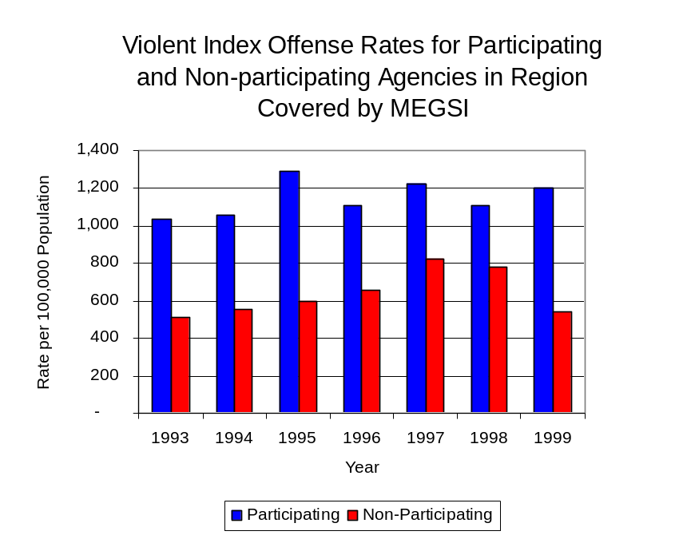
Source: ICJIA calculations using
Illinois State Police and U.S. Census Bureau data
Figure 1

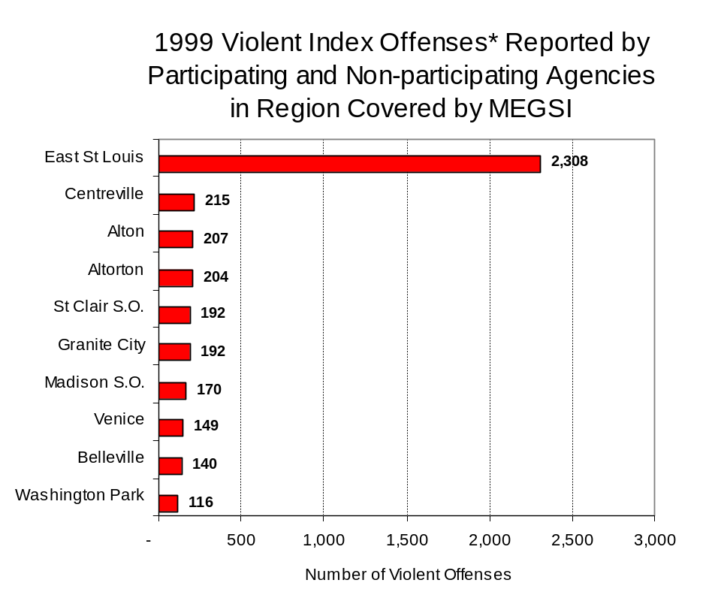
Across the 56 individual local law enforcement agencies covered by MEGSI’s jurisdiction, ten agencies accounted for 83 percent of all violent offenses reported to the police (Figure 2). Forty-six agencies had fewer than 100 violent offenses reported in 1999 and are excluded from Figure 2. When controlling for differences in the populations served by these law enforcement agencies, the violent Index offense rate ranged from zero in ten agencies to 28,780 violent Index offenses per 100,000 population in Sauget.
Source: Illinois State Police*Agencies reporting 100 or more
violent offenses
Figure 2

An indicator of the workload that law enforcement agencies place on other components of the justice system is the number of arrests made by police, including those for violent and property Index offenses and drug offenses. Unlike offenses, which are what police must respond to, arrests represent those offenders who may eventually be processed through other components of the justice system, including the courts, county jails, and state and local correctional programs.

Between 1993 and 1999, the number of arrests for violent Index offenses made by law enforcement agencies in the region covered by MEGSI increased 27 percent, from 1,649 to 2,096. As with reported violent Index offenses, the majority (85 percent) of violent Index arrests were for aggravated assaults, followed by robberies (8 percent).

During the period analyzed, the violent Index arrest rate for the region covered by MEGSI increased 26 percent, from 303 offenses per 100,000 population in 1993 to 383 arrests per 100,000 population in 1999. Similarly, the violent Index arrest rate in the participating agencies increased 44 percent, from 322 to 465 offenses per 100,000 population, while the rate in the non-participating agencies increased 7 percent, from 286 to 307 offenses per 100,000 population (Figure 3).

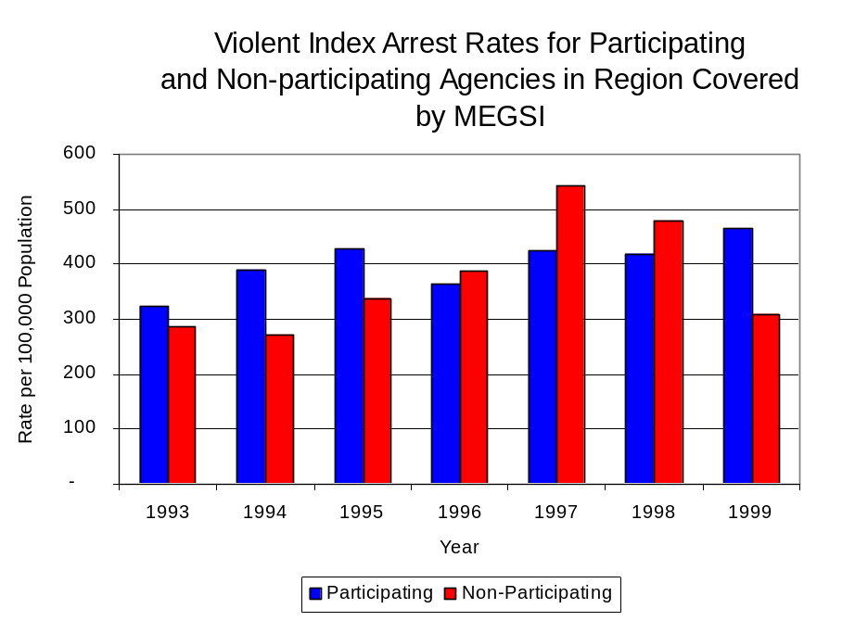
Similar to the number of violent Index offenses, the majority (78 percent) of arrests for violent Index offenses occurring in the three-county region covered by MEGSI were made by ten agencies. Forty-six agencies had fewer than 50 arrests for violent Index offenses reported in 1999 and are excluded from Figure 4. Of the 2,094 violent Index arrests made in 1999, the East St. Louis Police Department accounted for one-third, followed by Alton (8 percent), Centreville (7 percent), Alorton and Granite City (5 percent each), St. Clair and Madison County Sheriff's Offices and Venice (4 percent each) and Sauget and Belleville (2 percent each) (Figure 4).
Figure 3
Source: ICJIA calculations using
Illinois State Police and U. S. Census Bureau data

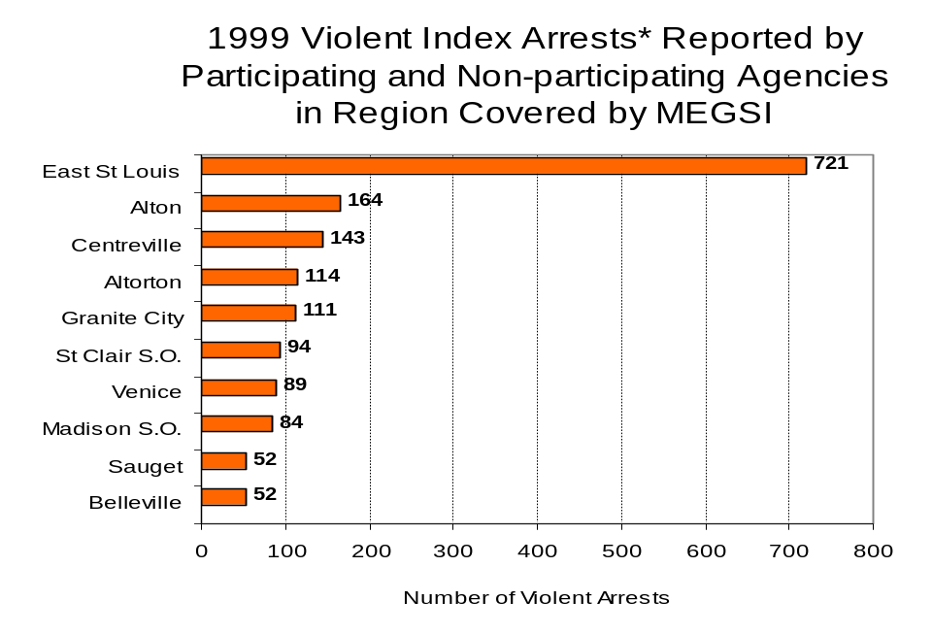
Figure 4
Source: Illinois State Police *Agencies reporting 50
or more violent offenses
III. Trends in Drug Arrests

There are two sources of drug arrest data presented in this section. One source is the Illinois Uniform Crime Reporting (I-UCR) program that includes information submitted by local law enforcement agencies on the number of persons arrested for violations of Illinois’ Cannabis Control Act, Controlled Substances Act, Hypodermic Syringes and Needles Act, and Drug Paraphernalia Control Act. In addition, data on drug arrests made by Illinois’ MEGs and task forces are reported to the Illinois Criminal Justice Information Authority. In some jurisdictions, arrests made by the MEG or task force may be reported by both local law enforcement agencies through the I-UCR and to the Authority by the unit. In other jurisdictions, arrests made by the MEG or task force are only reported to the Authority by the unit. Therefore, in some instances drug arrests may be double counted – included in both local agency statistics reported to I-UCR and those of the MEG or task force. Currently there is no mechanism in place to ensure that drug arrest statistics are not being duplicated at both the local agency and MEG/task force level. This should be kept in mind when interpreting the information presented in the following section.

The majority of drug offenses in Illinois are violations of either the Cannabis Control Act – which prohibits the possession, sale and cultivation of marijuana – or the Controlled Substances Act – which prohibits the possession, sale, distribution or manufacture of all other illegal drugs, such as cocaine and opiates. Illinois also has various other laws prohibiting other drug-related activity. These include the Hypodermic Syringes and Needles Act – which prohibits the possession or sale of hypodermic instruments – and the Drug Paraphernalia Control Act – which prohibits the possession, sale or delivery of drug paraphernalia. In general, violations of Illinois Controlled Substances Act are considered to be more serious, since they primarily involve cocaine, heroin, methamphetamine, and hallucinogens, and are almost all classified under Illinois law as felonies. The majority of cannabis and drug paraphernalia offenses encountered by police, on the other hand, tend to be misdemeanor-level offenses.

In 1999, local law enforcement agencies in the counties covered by MEGSI reported 3,505 arrests for drug law violations, more than double the number in 1993 (1,374 arrests). Between 1993 and 1999, arrests for violations of Illinois’ Cannabis Control Act consistently out-numbered arrests for violations of the Controlled Substances Act in five of the seven years analyzed in Madison, Monroe and St. Clair counties. During the same period, the number of arrests for violations of the Cannabis Control Act in these three counties more than doubled from 592 to 1,588. Arrests for violations of the Controlled Substances Act in the three counties combined increased 46 percent, from 726 to 1,064. In addition, arrests for violations of the Drug Paraphernalia Control Act, enacted in 1993, increased dramatically from 33 in 1993 to 817 in 1999. Much of this increase can be attributed to a 1994 addition to the Drug Paraphernalia Control Act, which included the possession of drug paraphernalia as a violation.

Because arrests for violations of the Drug Paraphernalia Control Act are frequently made in conjunction with other drug offense arrests, these arrests may be double-counted, thus skewing the actual number of drug arrests. Therefore, only arrests for violations of the Cannabis Control Act and Controlled Substances Act will be used for drug arrest comparisons between MEGSI and the participating and non-participating agencies.

During the period analyzed, the drug arrest rate for the Cannabis Control and Controlled Substances Acts, combined, in the region covered by MEGSI nearly doubled, from 242 arrests per 100,000 population in 1993 to 485 arrests per 100,000 population in 1999. The drug arrest rate in the participating agencies increased 59 percent, from 312 to 496 arrests per 100,000 population, while the drug arrest rate in the non-participating agencies more than doubled, from 180 to 475 arrests per 100,000 population. The arrest rate for MEGSI increased 29 percent, from 44 to 57 arrests per 100,000 population (Figure 5). Thus, the drug arrest rate tended to be slightly higher collectively in the jurisdictions that participated in MEGSI than in those jurisdictions that did not participate in MEGSI. The drug arrest rate achieved by the participating agencies was nearly nine times higher than the rate experienced by MEGSI, meaning that the unit, with 18 officers, made one arrest for a violation of the Cannabis Control or Controlled Substances Acts for every nine arrests made by all of the participating agencies combined.
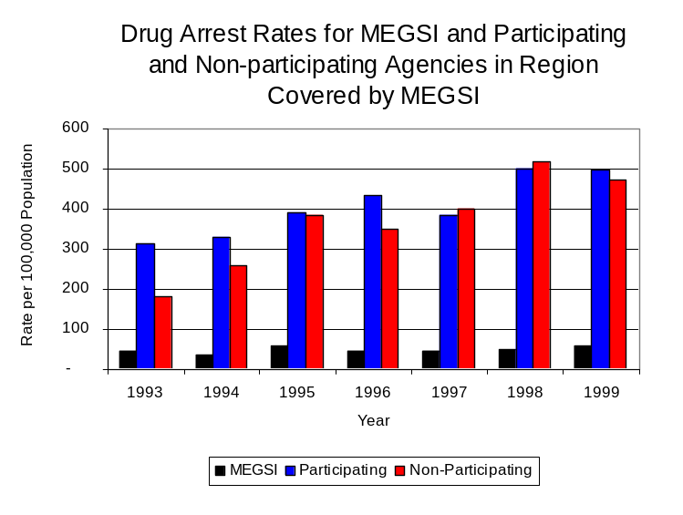
Source: ICJIA calculations using Illinois State Police and U.S. Census Bureau data
Figure 5

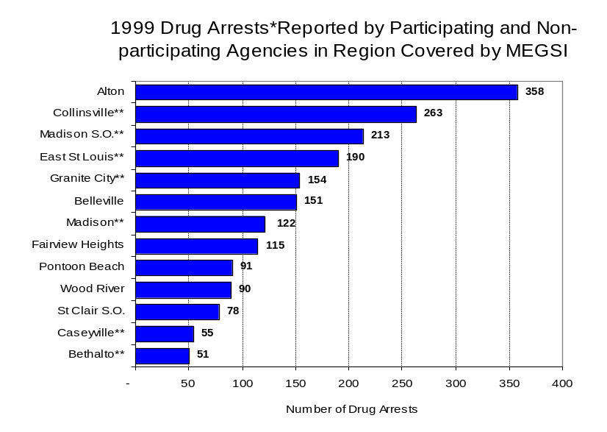
Across the individual local law enforcement agencies in the region covered by MEGSI, the total number of cannabis and controlled substances arrests ranged from zero in seven agencies to 358. Of the 2,638 drug arrests made during 1999 in the three-county region, 13 agencies accounted for nearly three-quarters (73 percent) of these drug arrests. Forty-three agencies had fewer than 50 drug arrests reported in 1999 and are excluded from Figure 6. Alton accounted for the largest proportion (14 percent) of cannabis and controlled substance arrests in Madison, Monroe and St. Clair counties, followed by Collinsville (10 percent), Madison (8 percent) and East St. Louis (7 percent) (Figure 6). Among the 13 agencies with the highest number of drug arrests during 1999, seven participated in MEGSI.
Figure 6
Source: Illinois State Police *Agencies reporting 50 or more drug arrests
**Agency does not participate in MEGSI

In addition to the dramatic difference in the number of drug arrests made, there are also
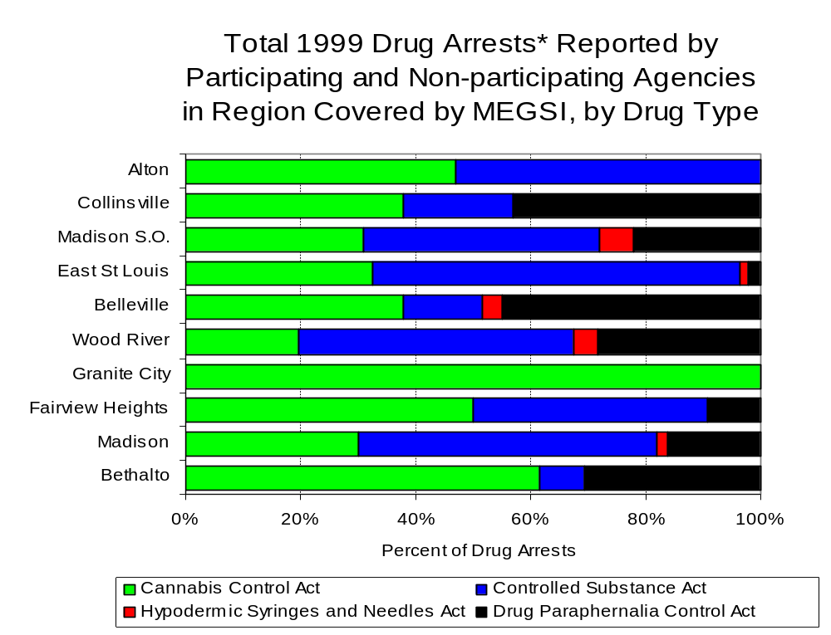
differences in the types of drug law violation arrests across the agencies in the region. In 1999, violations of the Cannabis Control Act accounted for the largest proportion of arrests across most individual agencies in the region covered by MEGSI (Figure 7).
Figure 7
Source: Illinois State Police *Agencies reporting 100 or more drug arrests

Between 1993 and 1999, the number of combined cannabis and controlled substances arrests made by MEGSI increased 32 percent, from 114 to 151 (Figure 8). Unlike drug arrests made by most local police departments in the region, violations of the Controlled Substances Act accounted for the majority of drug arrests made by MEGSI throughout most of the period analyzed. During the period analyzed, the number of MEGSI arrests for violations of the Cannabis Control Act decreased 4 percent, from 68 to 65, while arrests for violations of the Controlled Substances Act increased 87 percent, from 46 to 86 (Figure 8).

Between 1993 and 1999, the proportion of drug arrests accounted for by violations of the Controlled Substances Act decreased for participating and non-participating agencies as well as MEGSI. In 1999, 57 percent of the drug arrests made by MEGSI were for violations of the Controlled Substances Act, compared to 40 percent in 1993. Similarly, in 1999, arrests for controlled substances violations accounted for 43 percent of the drug arrests made in the participating agencies and 38 percent for the non-participating agencies, compared to 55 percent each in 1993. Thus, arrests by MEGSI were more likely than arrests by either participating or non-participating agencies to involve violations of Illinois’ Controlled Substances Act, as opposed to the Cannabis Control Act. One interpretation of this pattern is that MEGSI is more focused in who they are targeting and arresting than local departments, and are also getting a more serious drug law violator, since violations of the Controlled Substances Act are more likely to involve felony-level offenses.

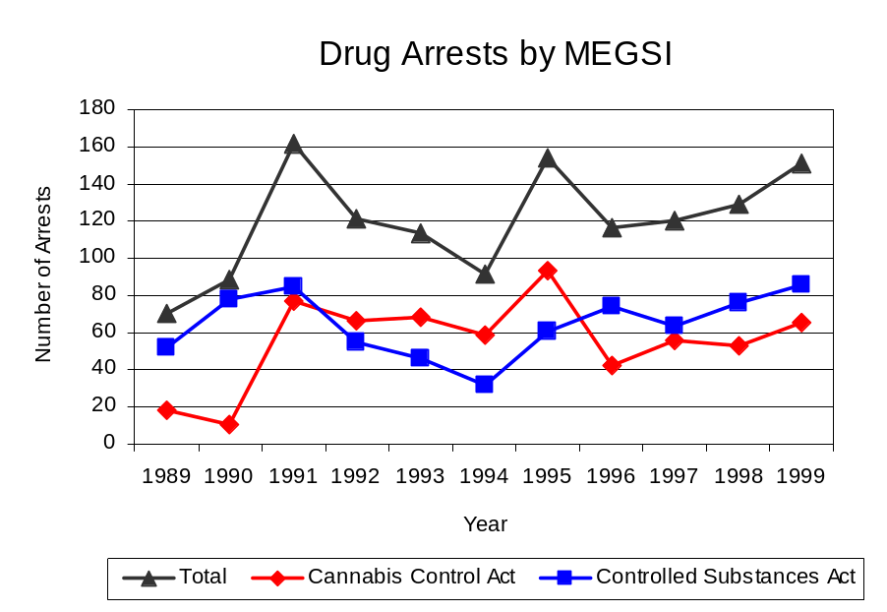
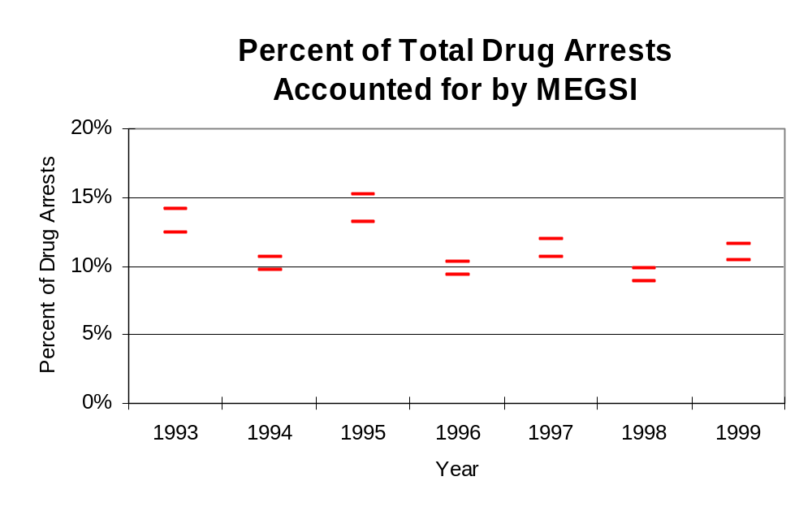
The data presented below represent the percent of total drug arrests made by agencies participating in MEGSI accounted for by MEGSI. An upper and lower bound is shown in Figure 9 which accounts for whether or not the units numbers are counted as part of the UCR submissions made by local departments (which is unknown at this point). The upper bound indicates the percentage of arrests if all of the MEGSI arrests are included in the local UCR submissions. The lower bound indicates the percentage if none of the MEGSI arrests are included in the local UCR submissions. It is estimated that the proportion of all drug arrests across participating agencies accounted for by MEGSI was between 12 to 14 percent in 1993, but decreased slightly to between 10 to 12 percent in 1999. Thus, despite the fact that the officers assigned to MEGSI accounted for a small proportion of total officers in the region, and unlike many other units, they accounted for more than 10 percent of the drug arrests in the region.
Source: MEGSI
Figure 8
Figure 9
Source: ICJIA calculations using
Illinois State Police and MEGSI data

The number of arrests for violations of Illinois’ Cannabis Control Act in Madison, Monroe and St. Clair counties totaled 1,576 in 1999, more than double the 592 arrests made for cannabis violations in 1993. Between 1993 and 1999, the proportion of all drug arrests accounted for by violations of the Cannabis Control Act in three-county region increased from 45 percent to 60 percent. Agencies not participating in MEGSI accounted for the largest portion (53 percent) of the total number of arrests for cannabis violations. MEGSI reported a total of 65 arrests for cannabis violations in 1999, 43 percent of the unit's drug arrests.

Between 1993 and 1999, the cannabis arrest rate for the region covered by MEGSI more than doubled, from 109 arrests per 100,000 population in 1993 to 288 arrests per 100,000 population in 1999. The cannabis arrest rate in the participating agencies also more than doubled, from 139 to 284 arrests per 100,000 population, while the cannabis arrest rate in the non-participating agencies more than tripled, from 82 to 293 arrests per 100,000 population. The cannabis arrest rate for MEGSI, on the other hand, decreased slightly, from 26 to 25 arrests per 100,000 population in 1999 (Figure 10). Thus, the arrest rate for violations of the Cannabis Control Act was collectively slightly higher in the non-participating agencies than in the combined jurisdictions of the participating agencies.
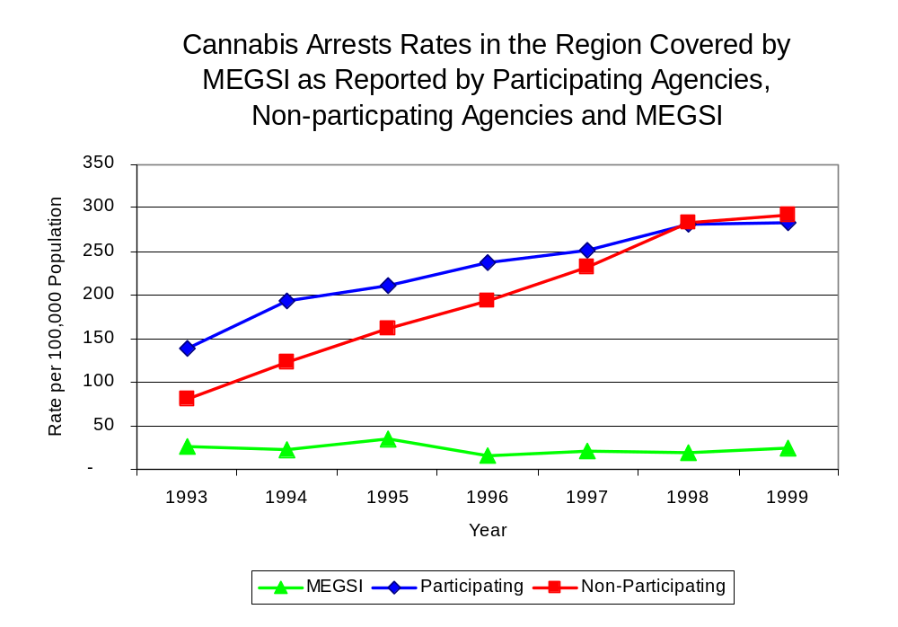
Source: ICJIA calculations using
Illinois State Police and MEGSI data
Figure 10
The data presented in Figure 11 represent the percent of cannabis arrests made by agencies participating in MEGSI accounted for by MEGSI. An upper and lower bound is shown which accounts for whether or not the unit’s numbers are counted as part of the UCR submissions made by local departments (which is unknown at this point). The upper bound indicates the percentage of arrests if all of the MEGSI arrests are included in the local UCR submissions. The lower bound indicates the percentage if none of the MEGSI arrests are included in the local UCR submissions. It is estimated that the proportion of cannabis arrests across participating agencies accounted for by MEGSI was between 16 and 19 percent in 1993, but decreased slightly to between 8 to 9 percent in 1999.

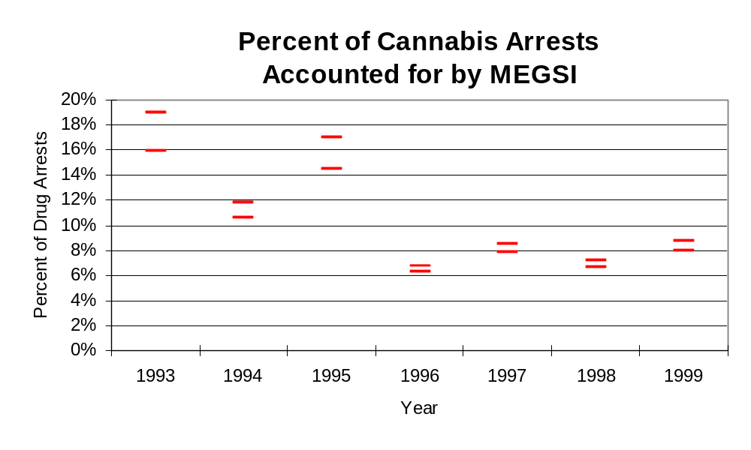
Figure 11
Source: ICJIA calculations using
Illinois State Police and MEGSI data
In Madison, Monroe and St. Clair counties, the number of arrests for violations of Illinois’ Controlled Substances Act increased 47 percent between 1993 and 1999, from 726 to 1,064. Between 1993 and 1999, the proportion of all drug arrests accounted for by violations of the Controlled Substances Act in three-county region decreased from 55 percent to 40 percent. Agencies participating in MEGSI accounted for the largest portion (53 percent) of the total number of arrests for controlled substances violations. In 1999, MEGSI reported 86 arrests for controlled substance violations, 57 percent of all drug arrests reported to the Authority by the unit.

Between 1993 and 1999, the arrest rate for controlled substances act violations for the region covered by MEGSI increased 46 percent, from 134 to 195 arrests per 100,000 population (Figure 12). The controlled substances arrest rate in the participating agencies increased 23 percent, from 173 arrests per 100,000 population in 1993 to 212 arrests per 100,000 population in 1999, while the arrest rate in the non-participating agencies nearly doubled, from 98 to 178 arrests per 100,000 population during the same period. The controlled substances arrest rate for MEGSI increased 82 percent, from 18 to 33 arrests per 100,000 population (Figure 12). Thus, the Controlled Substances Act arrest rate was higher in the participating agencies than the non-participating agencies.
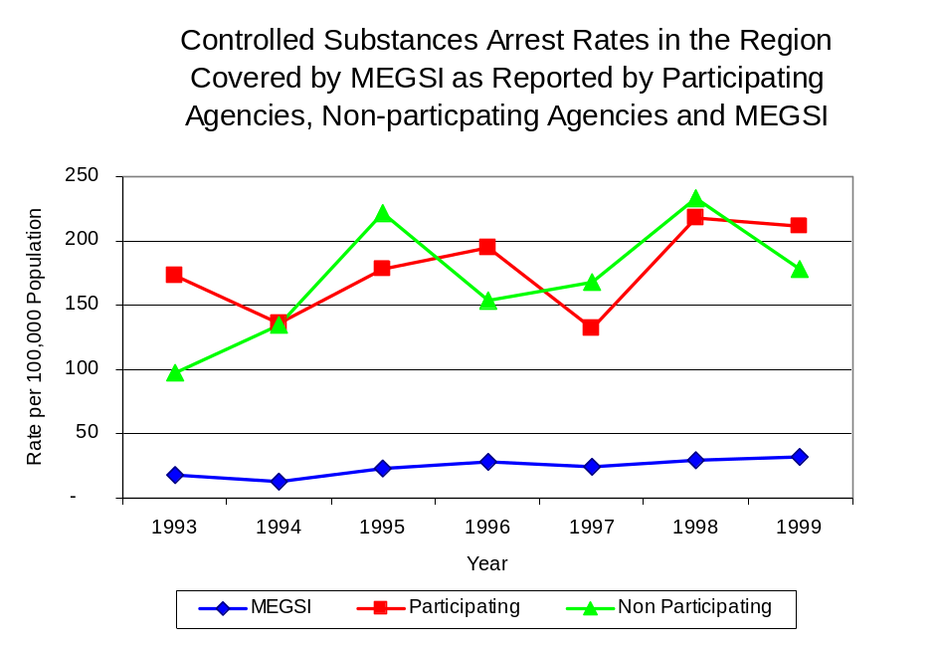
Figure 12
Source: ICJIA calculations using Illinois State Police and MEGSI data
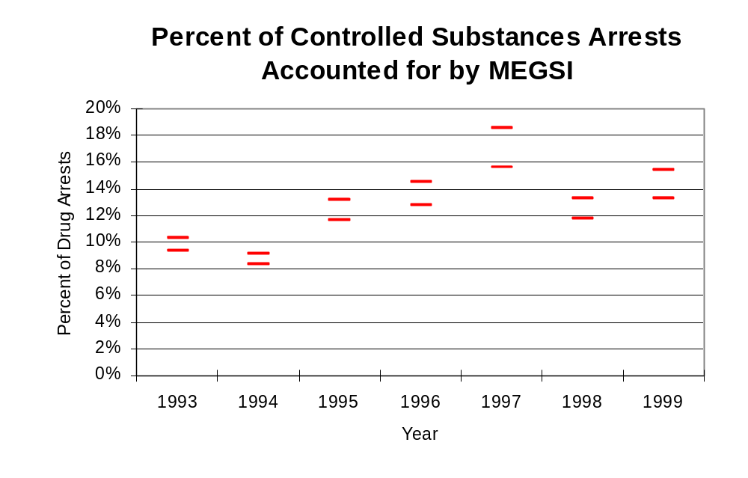
The data presented in Figure 13 represent the percent of controlled substances arrests made by agencies participating in MEGSI accounted for by MEGSI. An upper and lower bound is shown which accounts for whether or not the units numbers are counted as part of the UCR submissions made by local departments (which is unknown at this point). The upper bound indicates the percentage of arrests if all of the MEGSI arrests are included in the local UCR submissions. The lower bound indicates the percentage if none of the MEGSI arrests are included in the local UCR submissions. It is estimated that the proportion of controlled substances arrests across participating agencies accounted for by MEGSI was between 9 to 10 percent in 1993, and increased to between 13 to 15 percent in 1999.
Figure 13
Source: ICJIA calculations using Illinois State Police and MEGSI data

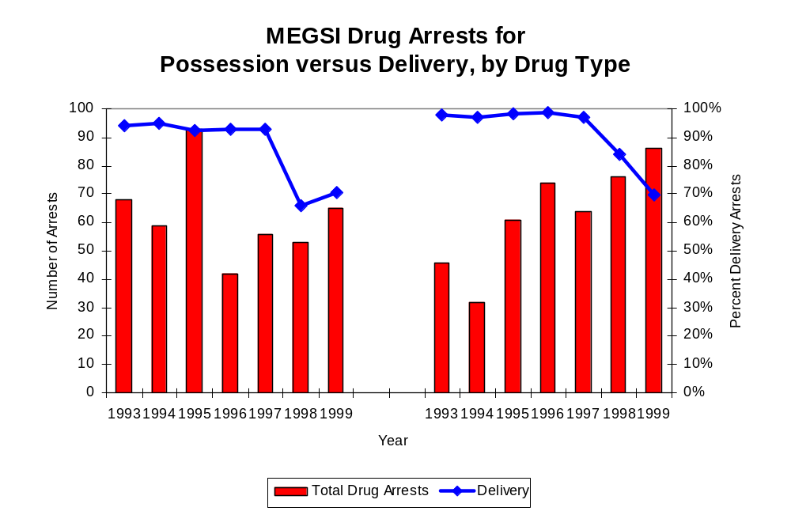
The majority of all drug arrests reported by MEGSI are for delivery. Arrests for drug delivery accounted for 88 percent of all drug arrests made by MEGSI between 1993 and 1999. During the period analyzed, the number of drug delivery arrests made by MEGSI decreased slightly, from 109 to 106. When cannabis and controlled substance arrests were examined separately, during the period analyzed, arrests for delivery of controlled substances accounted for 92 percent of the total number of arrests made for violations of the Controlled Substance Act, whereas, arrests for the delivery of cannabis accounted for 86 percent of all arrests for violations of the Cannabis Act. However, the proportion of delivery arrests has decreased during the period analyzed. The proportion of arrests for delivery of cannabis decreased from 98 percent in 1993 to 70 percent in 1999, while the proportion of arrests for delivery of controlled substances decreased from 94 to 71 percent between 1993 and 1999.
Figure 14
Source: ICJIA calculations using MEGSI data
Cannabis Control Act

Controlled Substances Act

IV. Trends in Drug Seizures

Drugs seized by law enforcement agencies are another indicator of the extent and nature of illegal drug trade in a jurisdiction. When illegal drugs are seized by law enforcement agencies, all or a portion of the total amount seized is submitted to a crime lab for analysis. Most agencies submit drugs to one of the Illinois State Police crime labs. These labs record the quantity of drugs submitted from each county. This section discusses trends in the quantities of illegal drugs seized and submitted to the Illinois State Police and the Madison, Monroe and St. Clair counties Sheriff's Office Crime Laboratory from local law enforcement agencies in Madison, Monroe and St. Clair counties as well as the quantities of drugs seized by MEGSI. It is important to note, however, that while MEGSI data report the total quantities of drugs actually seized, local agency data only represent the quantities of seized drugs that are submitted to the Illinois State Police for analysis. County-level cannabis, cocaine and methamphetamine seizure rates for Illinois' 102 counties are provided in maps located in the Appendix of this report.

As in most Illinois jurisdictions, cannabis accounts for the majority of illegal drugs seized in the region covered by MEGSI. The quantity of cannabis seized and submitted by law enforcement agencies in Madison, Monroe and St. Clair counties decreased 19 percent, from 1,157,729 grams in 1993 to 936,822 grams in 1999. However, the quantity of cannabis seized by MEGSI increased 14 percent between 1993 and 1999, from 246,298 grams to 280,375 grams despite jumping to 974,230 grams seized in 1995 (Figure 15). In 1999, MEGSI's cannabis seizure rate of 106,354 grams per 100,000 population was 38 percent lower than the cannabis seizure rate of 171,400 grams per 100,000 population in the three-county region covered by MEGSI (Map 2).

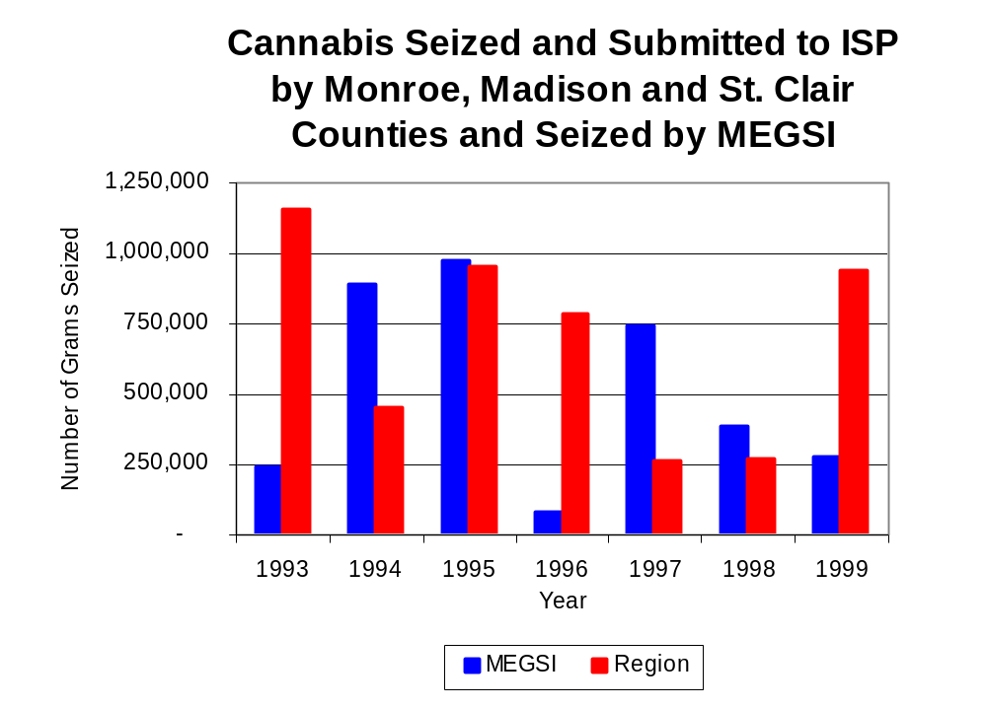
Figure 15
Source: Illinois State Police and MEGSI
Between 1993 and 1999, a combination of crack and powder cocaine has accounted for a small proportion of drugs seized in the three-county region covered by MEGSI. However, the quantity of cocaine seized and submitted by law enforcement agencies in Madison, Monroe and St. Clair counties increased 62 percent, from 14,847 grams in 1993 to 24,076 grams in 1999. Between 1993 and 1999, the quantity of cocaine seized by MEGSI increased 7 percent, from 5,516 grams to 5,900 grams.

The proportion of all cocaine seized in the three-county region covered by MEGSI accounted for by powder cocaine remained relatively stable between 1993 and 1999, increasing from 85 percent in 1993 to 93 percent in 1999, whereas MEGSI seizures revealed a bit more variation. In contrast, for MEGSI, although powder cocaine accounted for the largest proportion of total cocaine seizures in six of the seven years examined, the proportion decreased slightly, from 100 percent in 1993 to 97 percent in 1999, while declining to a period low of 31 percent in 1997 (Figure 16). In 1999, MEGSI's cocaine seizure rate of 2,238 grams per 100,000 population was one-half the cocaine seizure rate of 4,405ms per 100,000 population in the three-county region covered by MEGSI, but 86 percent less than the statewide cocaine seizure rate of 15, 735 grams per 100,000 population (Map 3).
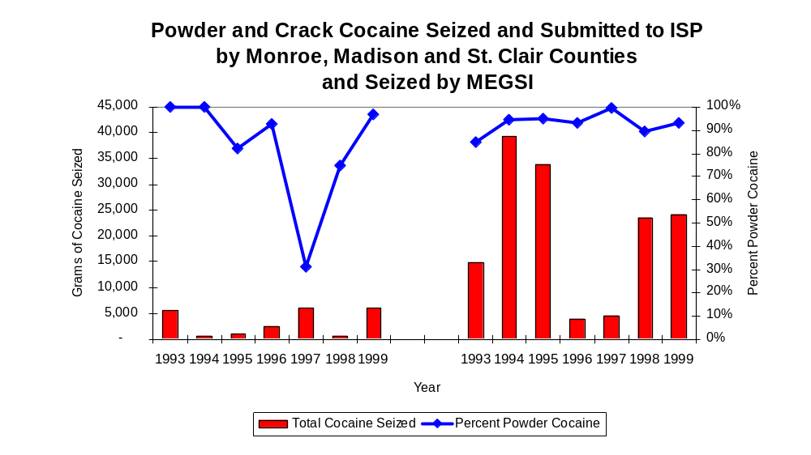
The total quantity of illegal drugs seized and submitted by law enforcement agencies in Madison, Monroe and St. Clair counties decreased 22 percent between 1993 and 1999, from 1,173,177 grams to 964,702 grams. Conversely, the total quantity of illegal drugs seized by MEGSI has increased 15 percent, from 251,901 grams in 1993 to 288,783 grams in 1999.
Figure 16
Source: Illinois State Police and MEGSI
MEGSI
Region

During the period, methamphetamine seizures accounted for a relatively small but increasing proportion of total drugs seized by MEGSI and the three-county region covered by MEGSI. Between 1993 and 1997, there were no reported methamphetamine seizures by MEGSI; however, the quantity of methamphetamine seized by MEGSI increased from 39 grams in 1998 to 2,313 grams in 1999. The quantity of methamphetamine seized by law enforcement agencies in the three-county region covered by MEGSI more than quadrupled, between 1993 and 1999, from 236 grams to 2,519 grams. In 1999, MEGSI had a methamphetamine seizure rate of 877 grams per 100,000 population, nearly double the rate of 461 grams seized per 100,000 population in the three-county region and dramatically higher than the statewide seizure rate of 98 grams per 100,000 population (Map 4).

Trends in Prosecutions for Drug Offenses and All Felonies

Although Illinois has one of the best court reporting systems in the country, the Administrative Office of the Illinois Court only collects information regarding the aggregate number of court filings. Currently, there are no statewide data available on court filings by offense type. The Administrative Office of the Illinois Courts reports data on felony criminal court cases. After screening a case and deciding it warrants further action, the state’s attorney must file formal charges in court. Felony cases can be punished by a probation term up to four years and incarceration for more than one year.

Between 1989 and 1999, the number of felony filings in the three-county region covered by MEGSI has increased nearly every year. During the period analyzed, the number of felony filings increased 66 percent, from 2,181to 4,630 (Figure 17).
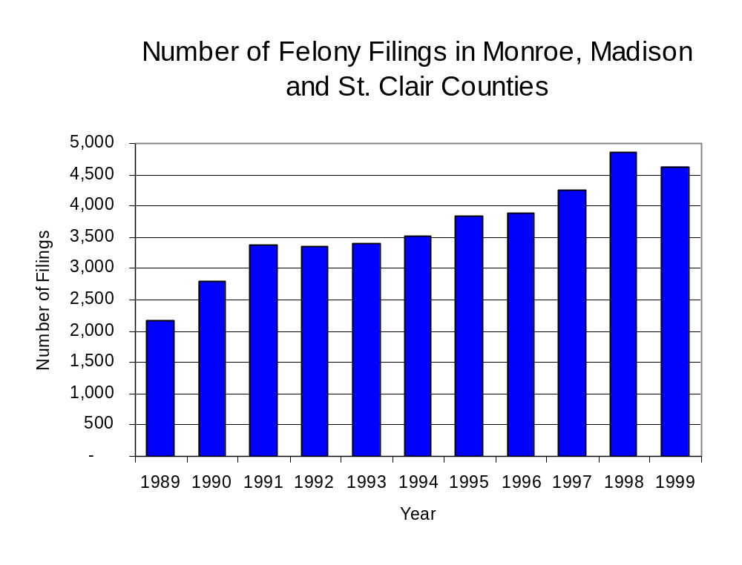
Figure 17
Source: Administrative Office of the Illinois Courts

Between 1989 and 1999, there were 1,177 drug prosecutions initiated as a result of MEGSI arrests in Madison, Monroe and St. Clair counties. During this time, the number of MEGSI drug more than doubled, from 70 arrests in 1989 to 151 arrests in 1999 (Figure 18). Between 1989 and 1999, nearly nine out of every ten drug arrests by MEGSI resulted in prosecution. While more than one-half (53 percent) of MEGSI drug offender prosecutions during this period were for violations of the Controlled Substance Act, the proportion of prosecutions accounted for by controlled substances has decreased from 81 percent in 1989 to 59 percent in 1999. In some years, the proportion of arrests resulting in a prosecution exceeded 100 percent. This is due to some slight differences in the timing of an arrest and the filings of charges, or could be due to charges, rather than defendants, being reported by the unit. In addition, some offenders have charges filed, and a subsequent warrant issued, without an arrest taking place.

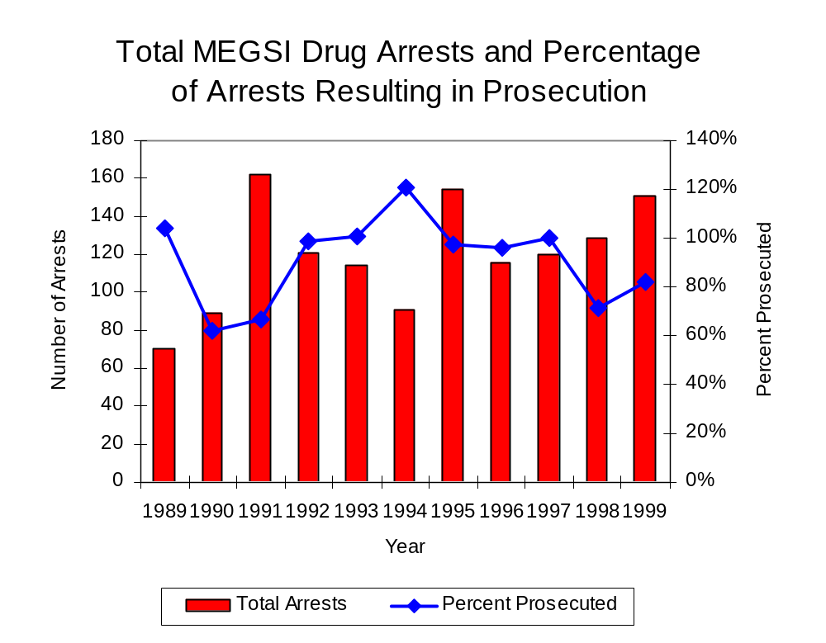
Figure 18
Source: MEGSI

Between 1989 and 1999, 87 percent (1,019) of the 1,177 drug offenders who were prosecuted as a result of MEGSI activity were convicted. Convictions for controlled substances accounted for 87 percent of all MEGSI initiated convictions during the period analyzed.

VI. Trends in Percent of Convicted Drug Offenders Sentenced to Prison

Anyone convicted of a felony in Illinois can be sentenced either to prison or probation, or receive conditional discharge. A number of factors influence the type and length of sentence imposed on convicted felons, including the severity of the crime, the offender’s criminal and social history, safety of the community and legislation affecting certain types of offenses. For some types of convictions, a sentence to prison is required by state statute.

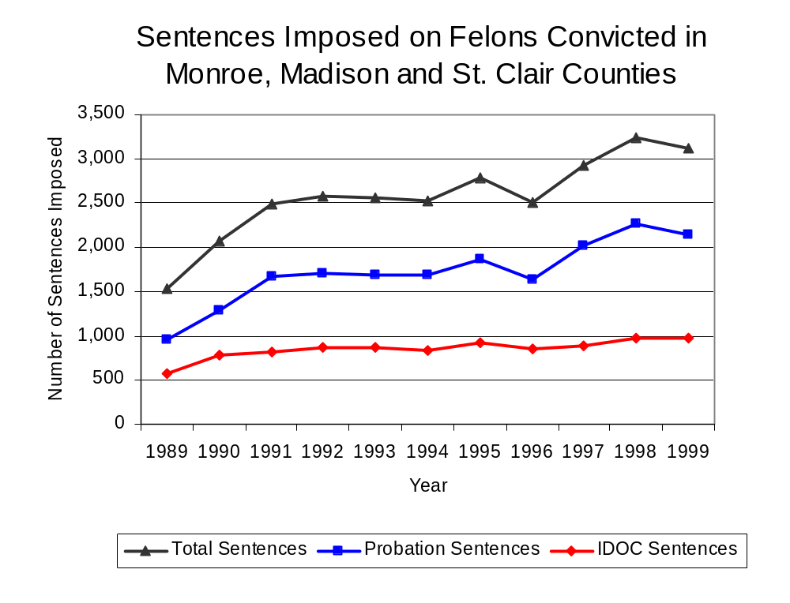
Between 1989 and 1999, the number of offenders convicted of a felony and sentenced in the three-county region covered by MEGSI more than doubled, from 1,530 to 3,214. The number of convicted felons sentenced to the Illinois Department of Corrections (IDOC) increased 70 percent between 1989 and 1999, from 569 to 967. However, the proportion of felons sentenced to IDOC decreased during the same period, from 37 percent to 31 percent of total felony sentences. In 1999, 2,143 probation sentences were imposed on convicted felons in Madison, Monroe and St. Clair counties, more than double the 960 probation sentences in 1989 (Figure 19). As a result, the proportion of felons sentenced to probation increased from 63 percent in 1989 to 69 percent in 1999. Sentences other than prison or probation accounted for less than 1 percent of the remaining felony sentences imposed in 1999.
Figure 19
Source: Administrative Office of the Illinois Courts

Between 1989 and 1999, the number of MEGSI drug offenders convicted and increased 70 percent, from 73 to 124. During the period analyzed, the number of convicted MEGSI drug offenders sentenced to either jail or probation increased between 1989 and 1999. The number of convicted MEGSI drug offenders sentenced to jail increased more than six-fold, from two to 15, while probation sentences increased 39 percent, from 66 to 92. However, the number of MEGSI drug offenders sentenced to prison decreased 36 percent, from 11 in 1989 to seven in 1999 (Figure 20). In 1999, among those MEGSI drug offenders convicted and sentenced, probation sentences accounted for the largest proportion (81 percent), followed by jail sentences (13 percent) and prison sentences (6 percent).
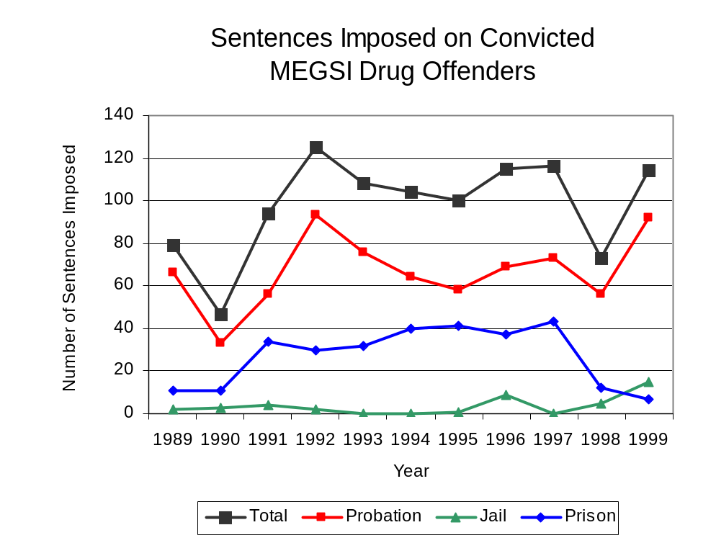
Figure 20
Source: MEGSI

Between state fiscal years 1989 and 1999, the number of new court commitments to IDOC’s Adult Division for drug offenses from Madison, Monroe and St. Clair counties more than doubled, from 32 to 115. However, the number of drug offender admissions by MEGSI decreased by 50 percent, from 14 to seven between 1989 and 1999 (Figure 21). Thus, while prison sentences resulting from MEGSI cases accounted for 21 percent of all drug-law violators sentenced to prison from the region where MEGSI operates during the period analyzed, the proportion of prison sentences accounted for by MEGSI decreased from 44 percent in 1989 to 6 percent in 1999.
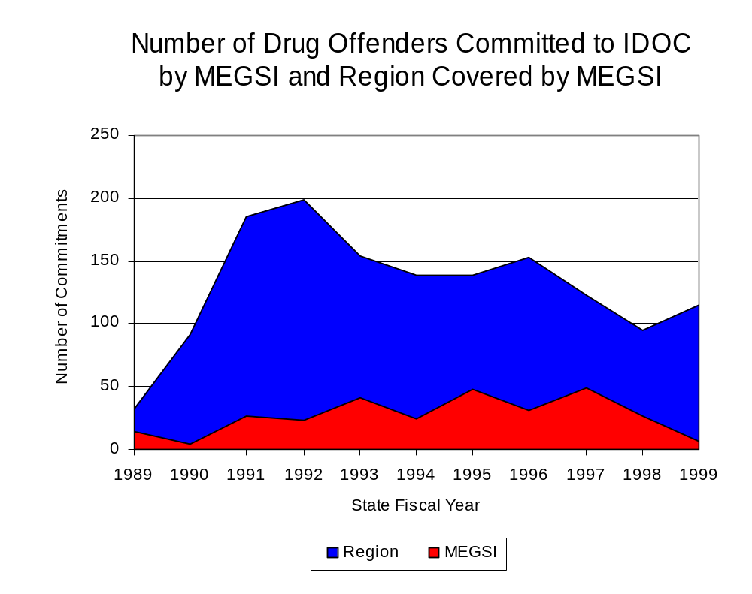
Figure 21
Source: Illinois Department of Corrections and MEGSI

During the period analyzed, drug offenders accounted for an increasing proportion of new court commitments to the Illinois Department of Corrections from Madison, Monroe and St. Clair counties. In 1989, drug offenses accounted for 6 percent of all commitments to IDOC, compared to 18 percent in 1999 (Figure 22).

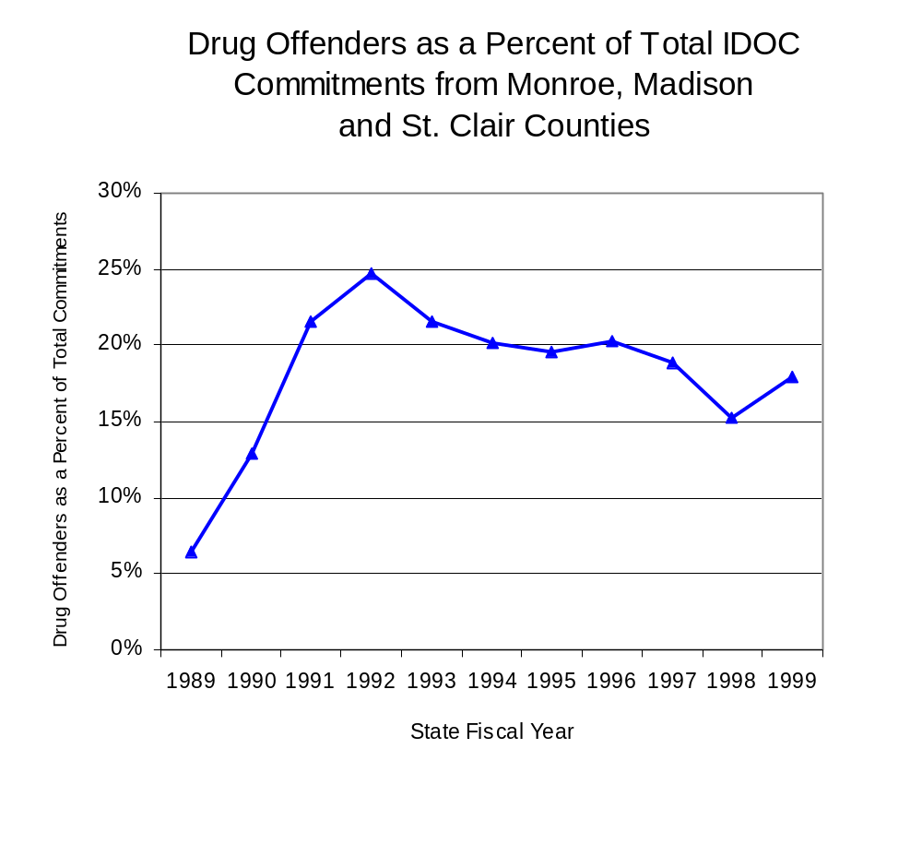
Figure 22
Source: Illinois Department of Corrections

Penalties for drug offenses were also examined between 1993 and 1999. Class 4 felonies accounted for the largest proportion (34 percent) of sentences to IDOC for drug offenses, followed by Class 2 felonies (29 percent), Class 1 felonies (24 percent), Class 3 felonies (9 percent) and Class X felonies (4 percent). Between 1993 and 1999, the number of Class 4 felony sentences doubled from 30 to 60. Conversely, between 1993 and 1999, the number of Class X felony sentences decreased from nine to three, while Class 2 felony sentences decreased 54 percent, from 46 to 21, Class 3 felonies decreased 30 percent, from ten to seven, and Class 1 felonies decreased slightly, from 25 to 24 (Figure 23).

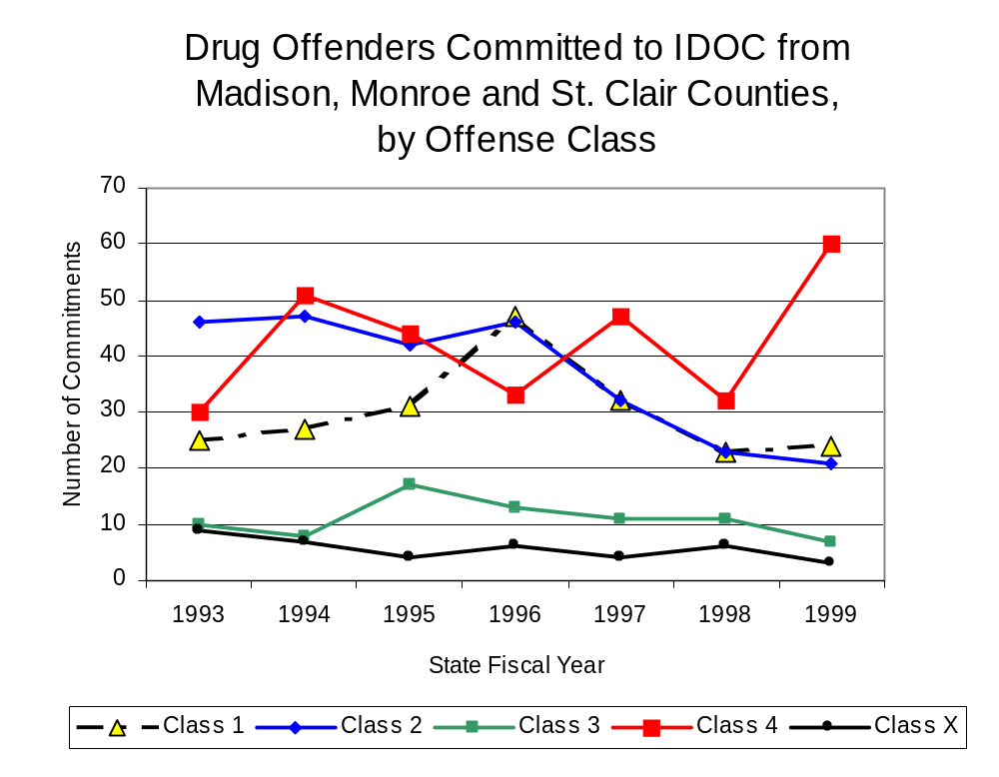
Figure 23
Source: Illinois Department of Corrections

Similar to the increase in Class 4 felony sentences to IDOC between 1993 and 1999, the mean sentence length for Class 4 felonies increased slightly from 1.6 to 1.8 years during the period. However, while the number of sentences decreased across the remaining Class types, the mean sentence lengths varied. The mean sentence length for Class 1 felonies increased from 4.5 to 5.3 years and Class X mean sentence lengths more than doubled, from seven years to 16 years. However, the mean sentence for a Class 2 and Class 3 felonies remained unchanged during the period analyzed, at four years and three years, respectively.

VII. Trends in Drug Treatment Admissions in MEGSI Region by Drug Type

In addition to considering indicators of the extent and nature of drug abuse as reported through the criminal justice system (for example, arrests and prison sentences), there are indicators of substance abuse available from other Illinois social service agencies. Overseeing and supporting treatment for substance users, whether they are referred from the criminal justice system or elsewhere, is the responsibility of the Illinois Department of Human Services’ Office of Alcoholism and Substance Abuse (OASA). It is important to note, however, that while OASA data represent the majority of the overall demand for substance abuse treatment in the state, some private programs provide treatment services to a smaller but significant number of clients who may not be included in the state’s reporting system.

In state fiscal year 1999, OASA reported 5,829 admissions for alcohol or drug abuse treatment from Madison, Monroe and St. Clair counties, 86 percent more than the 3,136 admissions in 1989 (Figure 24). Among the 5,829 admissions to substance abuse treatment in state fiscal year 1999, 35 percent (2,040) reported alcohol as their primary substance of abuse, while abuse of illicit substances accounted for 63 percent and 2 percent reported no primary substance of abuse.

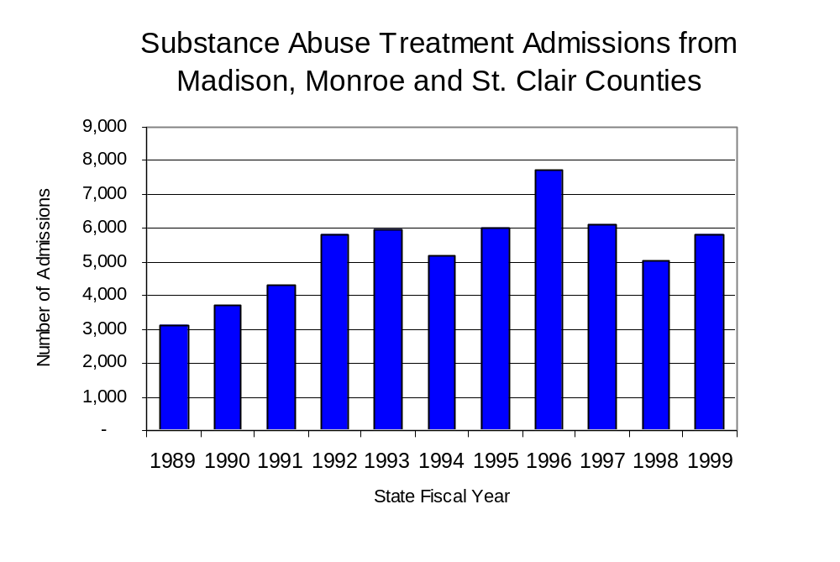
Figure 24
Source: Illinois Department of Human Services’
Office of Alcoholism and Substance Abuse
While drug treatment admissions can be considered a measure of the demand placed on a specific component of the human services system within Illinois, the extent and nature of drug treatment admissions could also be indicative of the substance abuse problem within a particular region. In some respects, the characteristics of those admitted to drug treatment can be considered a profile of the most serious drug abusers in the community, since admission to treatment requires a documented, formal assessment of a drug problem and a level of substance abuse warranting treatment. By comparing the types of drugs of abuse reported by those admitted to substance abuse treatment with the types of drugs involved in law enforcement agency arrests, one can get a sense of the degree to which arrests reflect the drugs which are most problematic within a community.

In the following analyses, the percent of arrests accounted for by drugs classified under Illinois’ Controlled Substances Act (primarily cocaine, heroin, and methamphetamine) versus the Cannabis Control Act (marijuana) across the participating agencies combined, non-participating agencies combined and MEGSI are compared to the proportion of drug treatment admissions accounted for by these groups of substances. From these comparisons, a number of general conclusions can be made. First, the proportion of arrests made by MEGSI accounted for by drugs other than marijuana (Controlled Substances Act offenses) was very close to the proportion of drug treatment admissions from the covered region accounted for by these substances. Thus, there is considerable convergence between the drugs involved in MEGSI arrests and treatment admissions. On the other hand, the majority of arrests by local police departments (including those participating in MEGSI and non-participating agencies) were for cannabis offenses. Thus, while local arrests may reflect the most widely available and used drug in the region, they tend not to involve the substances considered to be most serious (i.e., felony versus misdemeanor) nor the substances individuals are seeking and receiving treatment for (Figure 25).

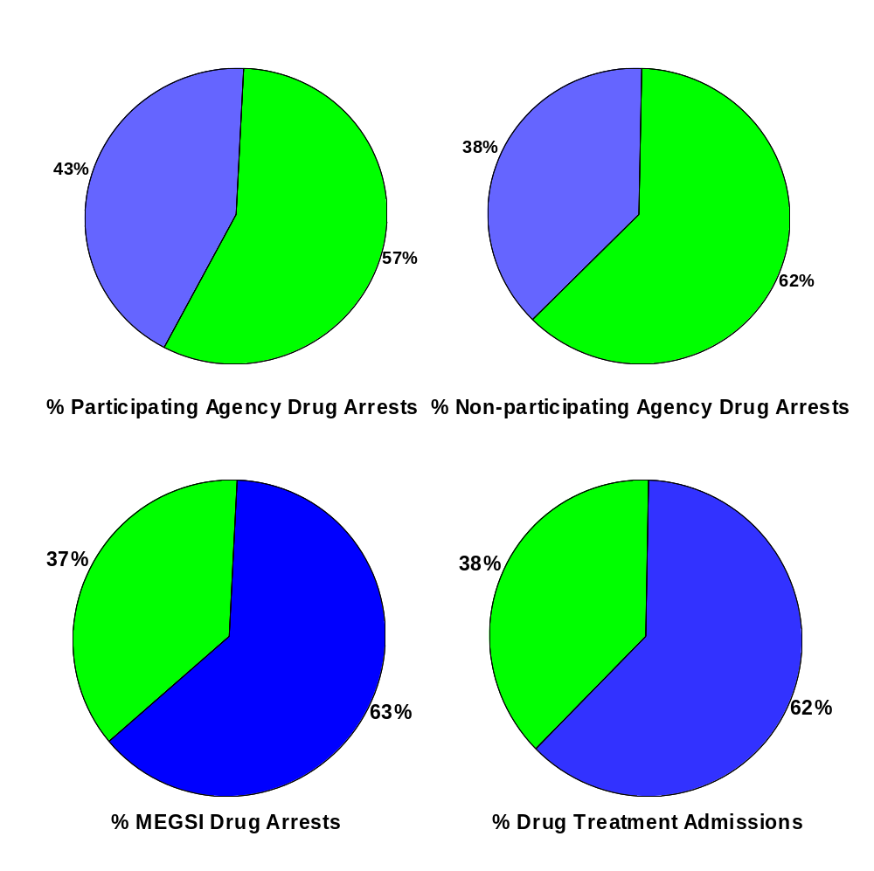
Source: ICJIA calculations using Illinois Department of Human Services’ Office of Alcoholism and Substance Abuse and MEGSI data

CannabisControlled Substances
Comparison of Drug Arrests by MEGSI and Participating and
Non-participating Agencies vs. Drug Abuse Treatment Admissions in Madison, Monroe and St. Clair Counties, 1999
Figure 25

VIII. Trends in Drug Exposed Births

Illinois continues to experience the effects of prenatal substance abuse. In Illinois, if a baby is born and thought to have been exposed to illegal substances or alcohol, either through observation by physicians or toxicology tests, the case is reported to the Illinois Department of Children and Family Services. These cases are then investigated by DCFS to verify the child’s prenatal exposure to either alcohol or illegal substances. Between state fiscal years 1989 and 1999, nearly one-half (50) of Illinois’ 102 counties reported at least one case of a substance-affected infant.

Although the number of drug-exposed infant cases reported in the three-county region covered by MEGSI nearly quadrupled, from 12 to 47 between state fiscal years 1989 and 1999, the number jumped dramatically to a period high of 135 in 1992 before declining nearly every year thereafter. Between state fiscal years 1989 and 1999, 772 cases, or 88 percent of all cases reported, were verified as involving prenatal drug use by a DCFS investigation. Mirroring the trend of reported cases, verified cases of drug-exposed infants in the MEGSI region increased from ten in 1989 to a period high of 124 in 1992 and has decreased annually to 36 in 1999 (Figure 26).
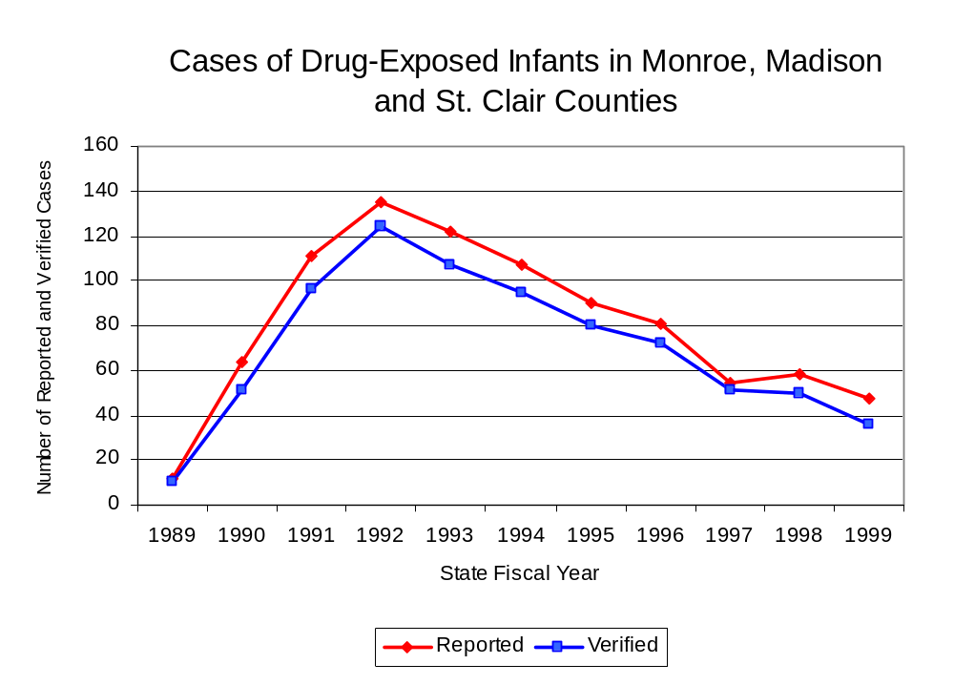
Source: Department of Children and Family Services
Figure 26
IX. Summary of Drug Situation

Although the distribution of illegal drugs is difficult to measure precisely, data obtained from criminal justice sources can be helpful in estimating drug availability. Information from a recent survey of Illinois drug enforcement units, as well as the most up-to-date data available on drug price, are presented as indicators of the drug supply in Illinois.

In 1995, 1996 and 1998, the Authority conducted a survey of each MEG and task force in Illinois to gauge the perceived availability of drugs in the areas they cover. Questions were asked concerning the availability of specific drugs, and results were analyzed by region of the state. MEGs and task forces are classified as being urban, rural or mostly urban based upon the classification of the county(s) that each unit covers, and, for purposes of this report, are compared to the average of similar units.

According to MEGSI survey responses, cannabis, cocaine and crack continued to be the most visible drugs on the street and were all reported to be “readily available” across all regions analyzed. While the perceived availability of most drugs remained relatively unchanged in the three-county region covered by MEGSI, the perceived availability of LSD has decreased slightly since the 1996 survey, while all other drug types increased slightly across Illinois and all MEGs and task forces in mostly urban regions similar to MEGSI. Methamphetamine was reported as moderately available across Illinois but available to a somewhat lesser degree in the three-county region covered by MEGSI and by all MEGs and task forces in mostly urban regions. Also, cocaine was reported as less available in the area covered by MEGSI than by all other MEGs and task forces in mostly urban regions and across Illinois. On the other hand, heroin appears to be more readily available in the three-county region covered by MEGSI than across Illinois or in all other MEGs and task forces in mostly urban regions (Figure 27).
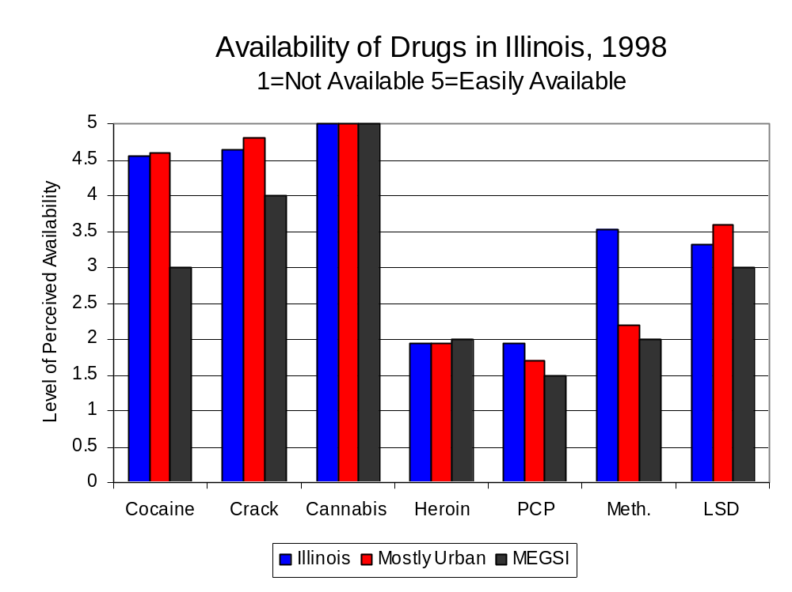
Figure 27
Source: Authority Survey of Illinois MEGs and task forces
Another market indicator that can be used to assess availability is drug price. Lower prices tend to suggest a sufficient supply to meet demand, while increasing prices indicate decreased availability.

Based on a statewide survey of MEG and task force units, the average price of cocaine, crack and methamphetamine appear to be relatively stable across all regions surveyed in 1998, while prices for PCP and heroin appear to vary somewhat across Illinois. The average price of crack and PCP in the region covered by MEGSI decreased between 1996 and 1998, while cocaine, heroin and cannabis increased. The 1998 average price of cocaine reported by MEGSI was $100 per gram, compared to $98 per gram across Illinois and $89 per gram reported by all MEGs and task forces in other mostly urban regions (Figure 28). On the other hand, the average price of heroin in the region covered by MEGSI was reported as approximately $100 per gram, lower than the price of $165 per gram across Illinois and the price of $137 per gram reported by all MEGs and task forces in other mostly urban regions. In 1998, the average price of cannabis was reported as approximately $5 per gram in the MEGSI region, $11 per gram in mostly urban regions and $8 per gram across Illinois.

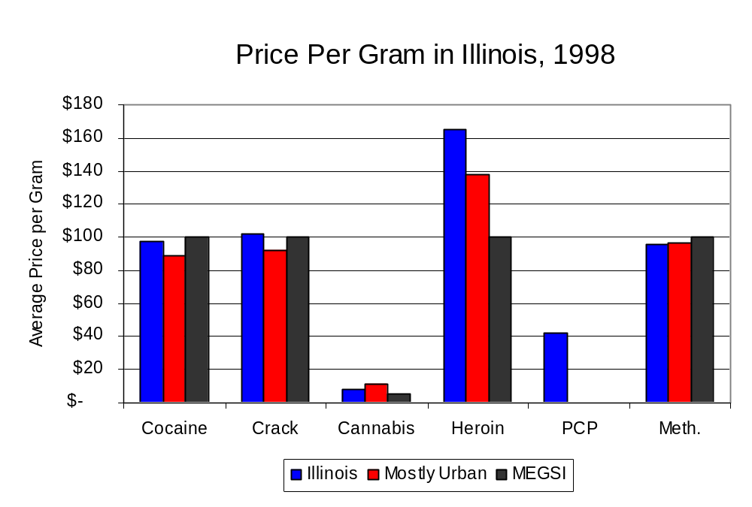
Figure 28
Source: Authority Survey of Illinois MEGs and task forces

X. Appendices
1999 Percent of Illinois'
County-level Population Covered by an Authority-funded Multi-jurisdictional Enforcement Group or Task Force
Map 1
* Shaded counties indicate that at least one law enforcement agency within the county participates in a MEG or task force
Percent of County Population Covered by MEG or Task Force

1999 Illinois
Cannabis
Seizure Rates, by County
Map 2
Cannabis Seizure Rate
(rate per 100,000 population)
1999 Illinois
Cocaine
Seizure Rates, by County
Map 3
Cocaine Seizure Rate
(rate per 100,000 population)
1999 Illinois Methamphetamine
Seizure Rates, by County
Map 4
Methamphetamine Seizure Rate
(rate per 100,000 population)

Bibliography

Administrative Office of the Illinois Courts, Annual Report to the Supreme Court of Illinois.
1989 through 1999 reports, Springfield, Illinois.

Administrative Office of the Illinois Courts’ Probation Division, Statewide Probation Data
Report. 1989 through 1999 reports, Springfield, Illinois.

Illinois Department of Human Services’ Office of Alcoholism and Substance Abuse. Data
provided for state fiscal years 1989 through 1999, Springfield, Illinois.

Illinois Department of Children and Family Services, Child Abuse/Neglect Statistics Report,
1989 through 1999 reports, Springfield, Illinois.

Illinois Department of Corrections. Data provided for fiscal years 1989 through 1999,
Springfield, Illinois.

Illinois State Police, Crime in Illinois. 1993 through 1999 reports, Springfield, Illinois.

Illinois State Police, Drug Statistics Report. Monthly reports, January 1989 through
December 1999, Springfield, Illinois.

Madison, Monroe and St. Clair counties Metropolitan Enforcement Group. Monthly reports, January
1989 through December 1999, Collinsville, Illinois.

U.S. Bureau of the Census.


George H. Ryan, Governor
Peter B. Bensinger, Chairman
Candice M. Kane, Executive Director

